
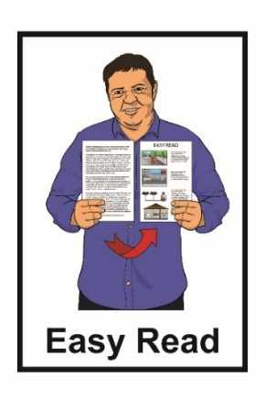

Long-term Insights
Briefing summary





Published: June 2025

What you will find in here

Page number:


About this Easy Read 4

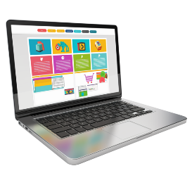
What is the topic for the Briefing
this year? 7


Storytelling in the future 10


Protecting stories in the future 12

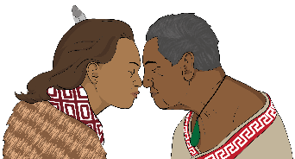
Te Ao Māori and technology 15

Page number:

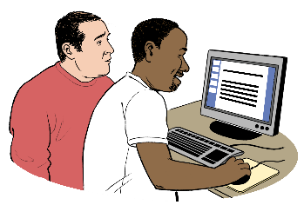
How does change make a
difference to our future
storytelling? 17

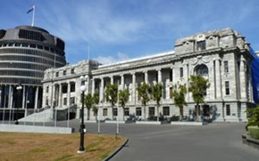
How can the government make
change? 20


Have your say on the Long-term
Insights Briefing 22

About this Easy Read

This Easy Read is a summary of a Long-term Insights Briefing.


A summary is:
shorter than the main document
tells you the main ideas.

Here long-term means looking:

15 years into the future from now
and
longer into the future.

The future is a time that has not happened yet.

Insights means understanding of a difficult topic.

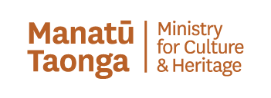
The Long-term Insights Briefing is from Manatū Taonga Ministry for Culture and Heritage.


Manatū Taonga Ministry for Culture and Heritage is a part of government that works on:
- arts like painting or music
- heritage like important old buildings

- media like television or newspapers.

In this document Manatū Taonga Ministry for Culture and Heritage will be called Manatū Taonga.

When you see we / us / our in this document it means Manatū Taonga.


We have to write this report every
3 years.

We choose a different thing to write about each time.

What is the Briefing about this year?

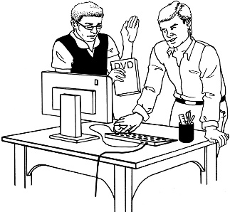
In this Briefing we chose to talk about how technology will affect storytelling in the future.

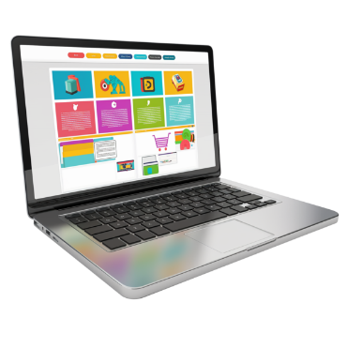
Here technology means things like:
computers
the internet.


We have written about how New Zealanders:
- make stories

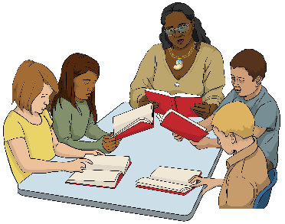
- share stories

- keep stories safe.

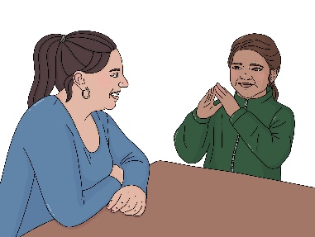
Stories could be:
people talking to each other
making movies and shows
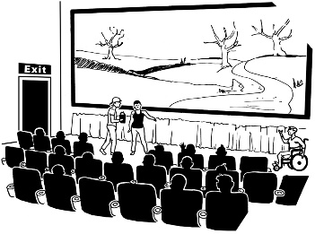
making art
recording history
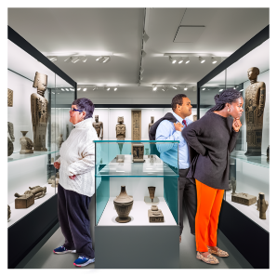
social media like Facebook
showing special objects like in a museum.

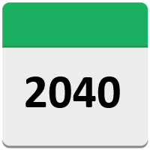
We think about what storytelling will be like in:
the year 2040
and
after that.


In the Briefing we talk about how people might express
themselves / tell their stories in the future.

Storytelling in the future

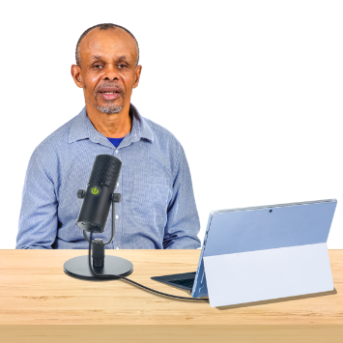
The Long-term Insights Briefing looks at how the digital tools we use will help us:
- do work
- be creative.


Here digital tools can mean things like:
computers
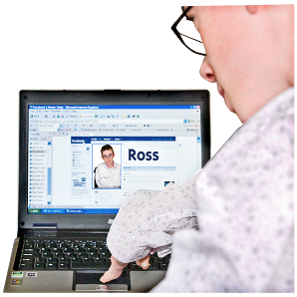
tablets
computer programs
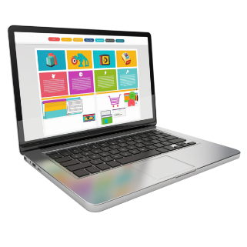
apps
the internet.

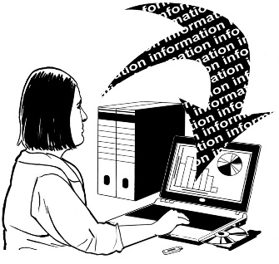
We think about how:
people get information
and
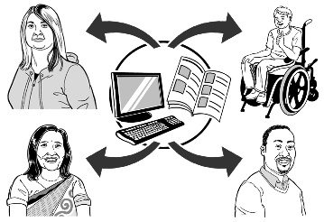
what type of information they get.

Protecting stories in the future

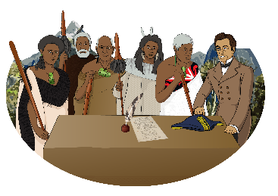
The Long-term Insights Briefing talks about protecting New Zealand:
history

and
identity.
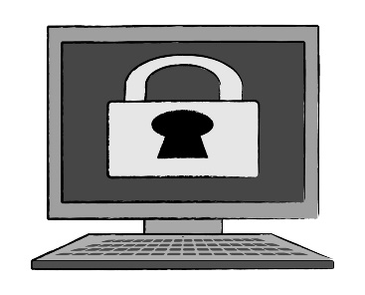

Protecting means keeping something safe.
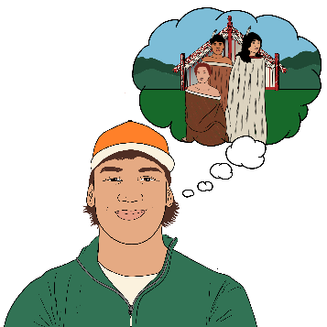

History means things that happened a long time ago.


Here identity means how New Zealanders see themselves.

Identity makes us:
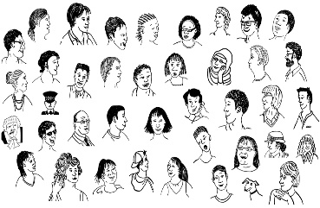
unique / not like anyone else
different.

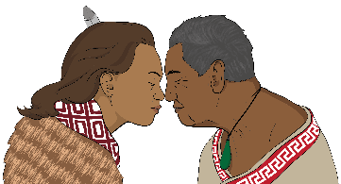
Identity includes things like:
beliefs

culture
experiences / things that happen to us.

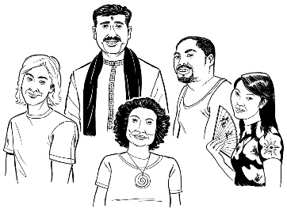
Culture is a way of:
thinking that a group shares
doing things as a group.
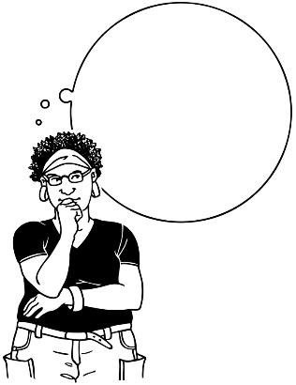

Protecting stories includes thinking about how we store information online.

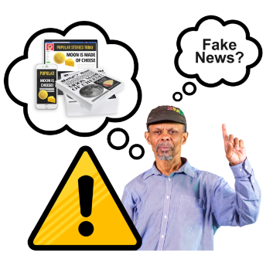
In the Briefing we think about the ways people can tell the difference between information that is:
real or true
fake or made up.

Te Ao Māori and technology

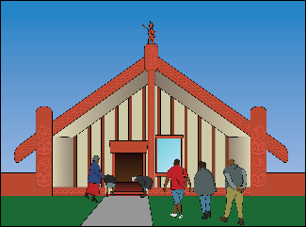
Te Ao Māori means seeing the world from a Māori point of view.

Te Ao Māori is unique to / not like anything else in New Zealand culture.

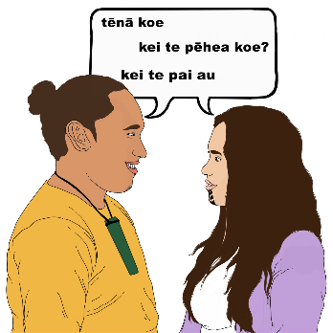
Māori knowledge includes:
te reo Māori / Māori language
Māori:
- history
- ways of doing things
- ways things have been done for a long time.

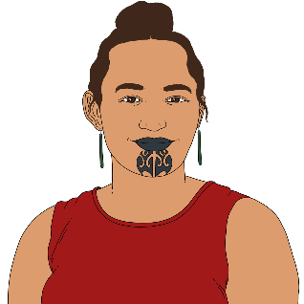

The Briefing talks about how technology can affect the way Māori tell stories.

How does change make a difference to our future storytelling?

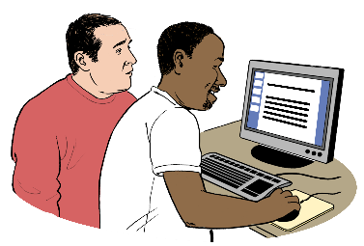
This Briefing looks at the things that could make a difference to our future storytelling like:
- changing technology

changing population including:
- age
- ethnicity

- less trust in things like:
- governments
- universities.

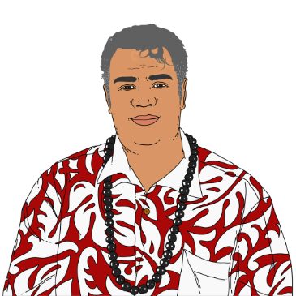
Ethnicity means your:
- race like:
  - Māori
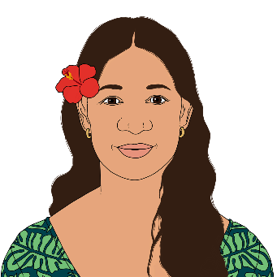
  - Samoan
  - Tongan
- background like whether you:
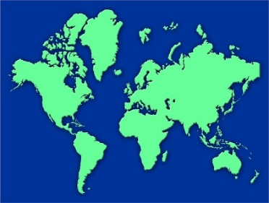
  - were born in Aotearoa New Zealand
  - moved to Aotearoa New Zealand from another country.


This Briefing also looks at the things that could make a difference to our future storytelling like:
- people who:



- have technology
- do not have technology
- people getting information they are not allowed to.

How can the government make change?

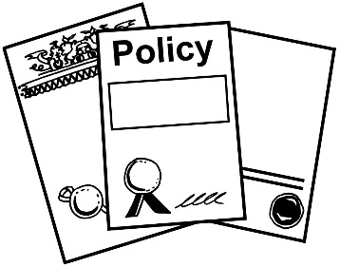
The Briefing talks about policy options to deal with future problems with:
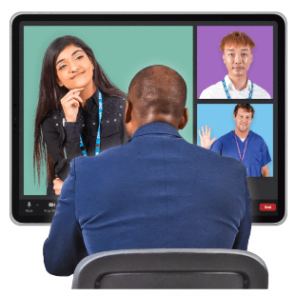
technology
and
storytelling.


Here policy options means different kinds of rules for how the government does things.


Each policy option looks at:
how much it would deal with the problem
how hard it would be to do
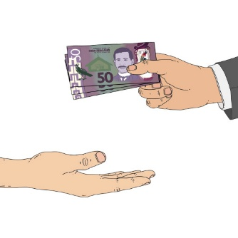
how much it would cost
risks / what could go wrong.

Have your say on the Long-term Insights Briefing

We want to hear what people think about the draft Long-term Insights Briefing.

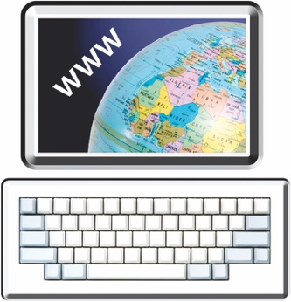
You can read the Briefing at our website:

www.mch.govt.nz


The Long-Term Insights Briefing is not in Easy Read.


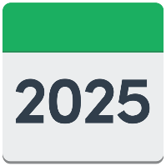
You have until 6 July 2025 to have your say.

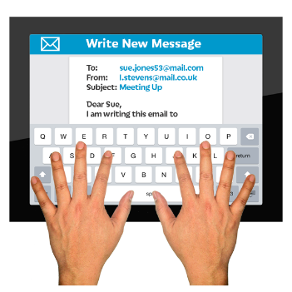
You can have your say by contacting our team by email at:

ltib@mch.govt.nz

You can post your answers to:
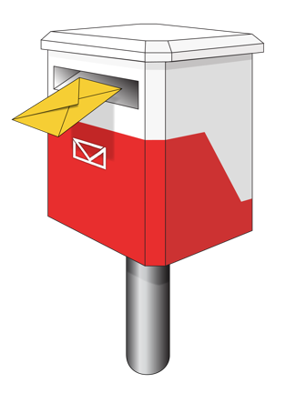
LTIB team
Manatū Taonga Ministry for Culture and Heritage
PO Box 5364
Wellington 6140

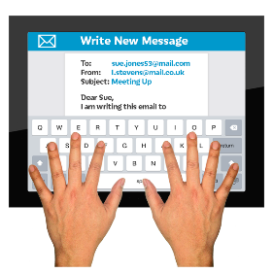
If you would like us to talk to us about what you want to say:
email us with your phone number

and
we will call you.


If you find it hard to use the phone the New Zealand Relay service is for people who are:

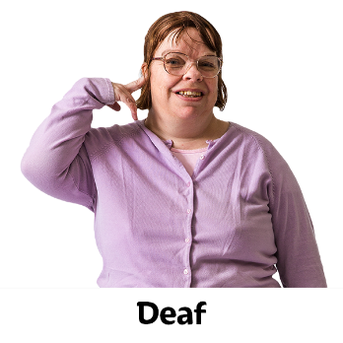
- Deaf / hard of hearing

- deafblind

- speech impaired / find it hard to talk.

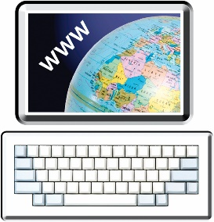
You can find out more about the New Zealand Relay service at:

www.nzrelay.co.nz
This information has been written by
Manatū Taonga Ministry for Culture and Heritage.

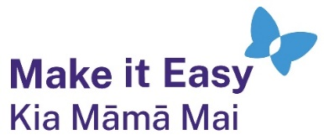
It has been translated into Easy Read with advice from the Make it Easy Kia Māmā Mai service of People First New Zealand Inc. Ngā Tāngata Tuatahi.
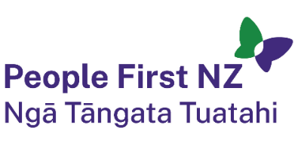
The ideas in this document are not the ideas of People First New Zealand Ngā Tāngata Tuatahi.

All images used in this Easy Read document are subject to copyright rules and cannot be used without permission.


Make it Easy uses images from:

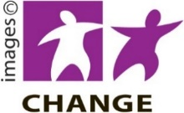
- Photosymbols

- Change Images



- Huriana Kopeke-Te Aho

- SGC Image Works


- T Wood

- Studio Rebeko.

